# **Master’s Thesis:** **Pre-manipulation for grasping – Using Model-free Visual Reinforcement Learning for fabric manipulation to expose a flat seam for grasping operation**

## Background

Deformable object manipulation is a significant problem in robotics due to two major challenges – unclear state representation and complex non-linear dynamics. A model-free visual policy based learning approach is one of the recent breakthroughs towards fabric manipulation as it does not require an explicit model, thereby avoiding to deal with the challenge of complex fabric dynamics. State estimation for deformable objects is also overcome since we directly learn on images.

## Description

Sewts GmbH is a TUM-based startup focused on delivering computer vision and robotics solutions for textile handling. At sewts, the primary problem is that of flattening a fabric, in this case a towel, using a pipeline based on a set of robots in order to feed it to a folding machine. For this the fabric is fed to a cartesian robot by a manipulator arm which grabs a portion of an exposed flat seam and feeds it to the cartesian type robot for fully straightening it. The exposure of the flat seam region to make it usable for further grasping is called pre-manipulation. Currently this is being done by a separate robot which grasps the fabric and places on top of a mechanical assembly which increases the chances of exposing the seam. Since we are using a mechanical arrangement to increase the probability of getting a seam and the dynamics of the fabric are highly uncertain, we do not always get the desired amount of the exposed seam. In cases when we do not get a proper exposed seam, the towel is rejected and the process is repeated. By using a model-free visual reinforcement learning approach, the aim of this thesis is to automate the process of exposing a region of the flat seam. Thereby the scope of the thesis involves successful completion of the following tasks :

* Exploration of existing simulation platforms for cloth simulation
* Selection of a suitable simulation environment
* Creation of synthetic images as input for the visual reinforcement learning task
* Exploration and comparison of existing deep reinforcement learning approaches
* Selection of a suitable learning algorithm for the task
* Performing domain randomization to transfer the policy to a real robot
* Exploration of alternate techniques to perform sim-to-real transfer
* Exploration of acceleration techniques like Hindsight Experience Reply and Imitation Learning to promote faster convergence
* Incorporation of one or more acceleration techniques depending on the convergence improvement in the existing pipeline

## Problem Statement

## Using Model-free Visual Reinforcement Learning for fabric manipulation to expose a flat seam in simulation and transfer it to a real robot for grasping operation, and exploration and incorporation of techniques that promote better performance and faster convergence to a desirable solution.

## Methodology

In order to solve the above research problem, the following steps are proposed :

1. **Literature review of existing reinforcement learning approaches for flattening** : Existing approaches for solving the folding problem using reinforcement learning are explored and a few specific approaches are selected for the task
2. **Literature review of existing simulation platforms** : Available simulation platforms are explored and judged on their suitability for our particular problem and the quality of fabric simulation that each offer and a particular simulation platform is chosen
3. **Synthetic dataset creation for visual reinforcement learning task** : Creation of a synthetic dataset using the chosen simulation platform
4. **Utilising domain randomization to perform sim-to-real transfer on a UR5 Robot** : This primarily involves making use of existing domain randomization approaches to perform robust sim-to-real transfer
5. **Exploration of existing approaches to transfer the learning to a real robot** : The specific goal of the exploration is to find out approaches alternate to domain randomization that may give more accurate results for sim-to-real transfer
6. **Exploration of strategies to promote faster convergence** : Exploration of acceleration techniques like Hindsight Experience Reply and Imitation Learning to promote faster convergence
7. **Incorporation of promising strategies on the existing pipeline** :The acceleration techniques that prove to improve performance are incorporated in the existing pipeline including the sim-to-real transfer

## Project Plan

## **Phase 1 : Topic Development : 28 days (Jan)**

## Literature Review of fabric manipulation : 7 days

## Topic Finalization : 7 days

## Proposal Preparation : 7 days

## Plan Preparation and proposal Finalization : 7 days

## **Phase 2 : Literature Review : 15 days (Feb)**

## Literature review of existing reinforcement learning approaches for flattening tasks : 15 days

**Phase 3 : Implementation : 52 days (mid Feb- early Apr)**

1. Setting up the Reinforcement Learning Platform and Simulation environment : 13 days
2. Prepare a custom implementation taking existing states, actions, rewards : 9 days
3. Redefine actions and rewards for our use case : 15 days
4. Test the pipeline and iterate : 15 days

**Phase 4 (Additional): Sim-to-real transfer : 28 days (early Apr- early May)**

*Master’s Thesis Registration*

1. Perform domain randomization : 7 days
2. Transfer to real robot : 21 days

**Phase 5 (Additional): Enhancement : 31 days (May)**

1. Exploration of alternate sim-to-real transfer approaches

and Exploration of acceleration strategies : 10 days

1. Incorporation of a proven acceleration approach : 15 days

**Phase 6 : Compilation : 30 days (June)**

1. Report and presentation compilation : 30 days

*Submission*

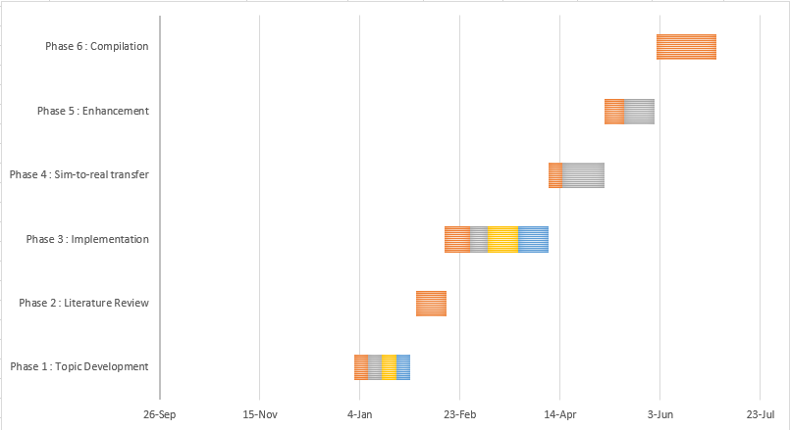

## Project Plan Updation

|  |  |  |  |
| --- | --- | --- | --- |
| **S. No.** | **Date** | **Change** | **Reason** |
| **V2** | 02/02/2021 | Added Sim-to-Real Transfer as separate Phase (Phase 4) | - |
|  |  | Made Phase 4, 5 additional | Would be updated depending on progress |
|  |  | Updated Sim-to-real transfer robot from 15 to 21 days | To add buffer time |
|  |  | Changed exploration time in enhancement from 14 to 10 days | To compensate for the added buffer time in Sim-to-real transfer |
| **V3** | 02/03/2021 | **Planned**   * **Phase 3 : Implementation : 52 days (mid Feb- early Apr)**  1. Testing various simulation environments and selecting one : 13 days 2. Setting up the Reinforcement Learning Platform and Simulation environment : 9 days 3. Dataset generation on chosen simulation platform : 15 days 4. Perform Reinforcement Learning using PyTorch : 15 days   **Update**   * **Phase 3 : Implementation : 52 days (mid Feb- early Apr)**  1. Setting up the Reinforcement Learning Platform and Simulation environment : 13 days 2. Prepare a custom implementation taking existing states, actions, rewards : 9 days 3. Redefine actions and rewards for our use case : 15 days 4. Test the pipeline and iterate : 15 days | Updated plan according to the progress |
| **V3** | 13/04/2021 | **Planned**  **Phase 3 : Implementation : 52 days (mid Feb- early Apr)**   1. Setting up the Reinforcement Learning Platform and Simulation environment : 13 days 2. Prepare a custom implementation taking existing states, actions, rewards : 9 days 3. Redefine actions and rewards for our use case : 15 days 4. Test the pipeline and iterate : 15 days   **Phase 4 (Additional): Sim-to-real transfer : 28 days (early Apr- early May)**  *Master’s Thesis Registration*   1. Perform domain randomization : 7 days 2. Transfer to real robot : 21 days   **Phase 5 (Additional): Enhancement : 31 days (May)**   1. Exploration of alternate sim-to-real transfer approaches   and Exploration of acceleration strategies : 10 days   1. Incorporation of a proven acceleration approach : 15 days   **Update**  **Phase 3 : Implementation : 52 +22 days (mid Feb- end Apr)**   1. Setting up the Reinforcement Learning Platform and Simulation environment : 13 days 2. Prepare a custom implementation taking existing states, actions, rewards : 9 days 3. Redefine actions and rewards for our use case : 15 days 4. Test the pipeline and iterate : 15 days   *(+22 days for g) and h) )*  **Phase 4 (Additional): Sim-to-real transfer : 31 days (May)**  *Master’s Thesis Registration*   1. Perform domain randomization : 7 days 2. Transfer to real robot : 21 days | Require more time to get valid results with SAC Algorithm |